**Points to change in the logistic project**

1.- Intead of calling projects we are going to name it contracts Done

2.- Here I cannot see the mane of the employees and the vehicles. Done

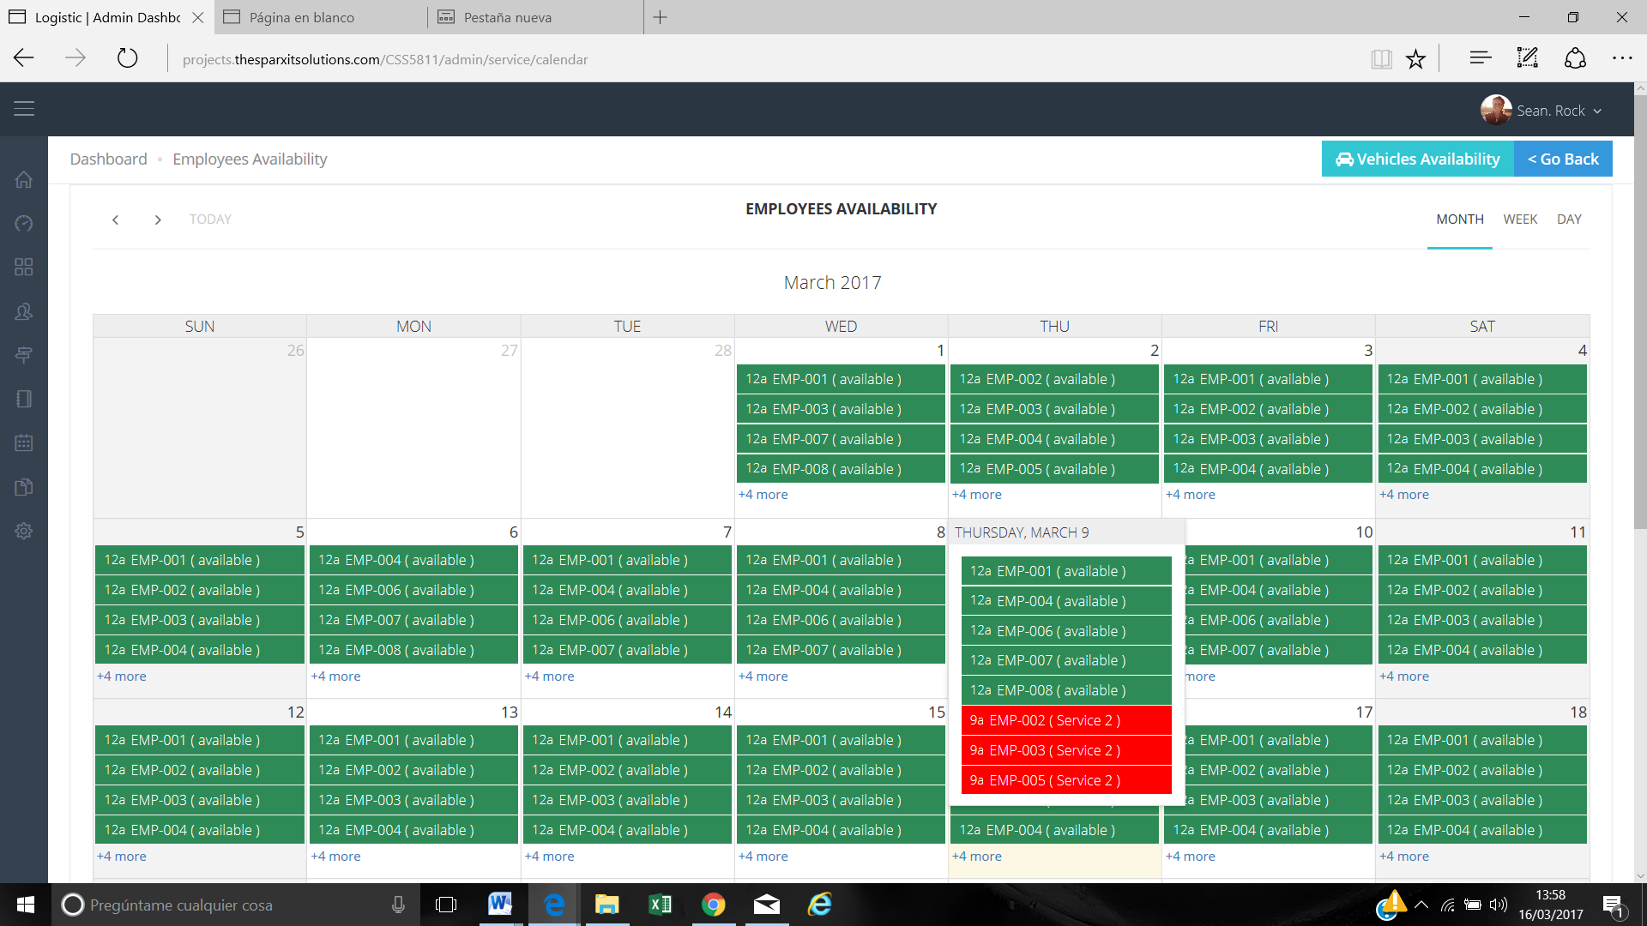

3.- In this screen we need to see directly the names of the employees and the vehicles.

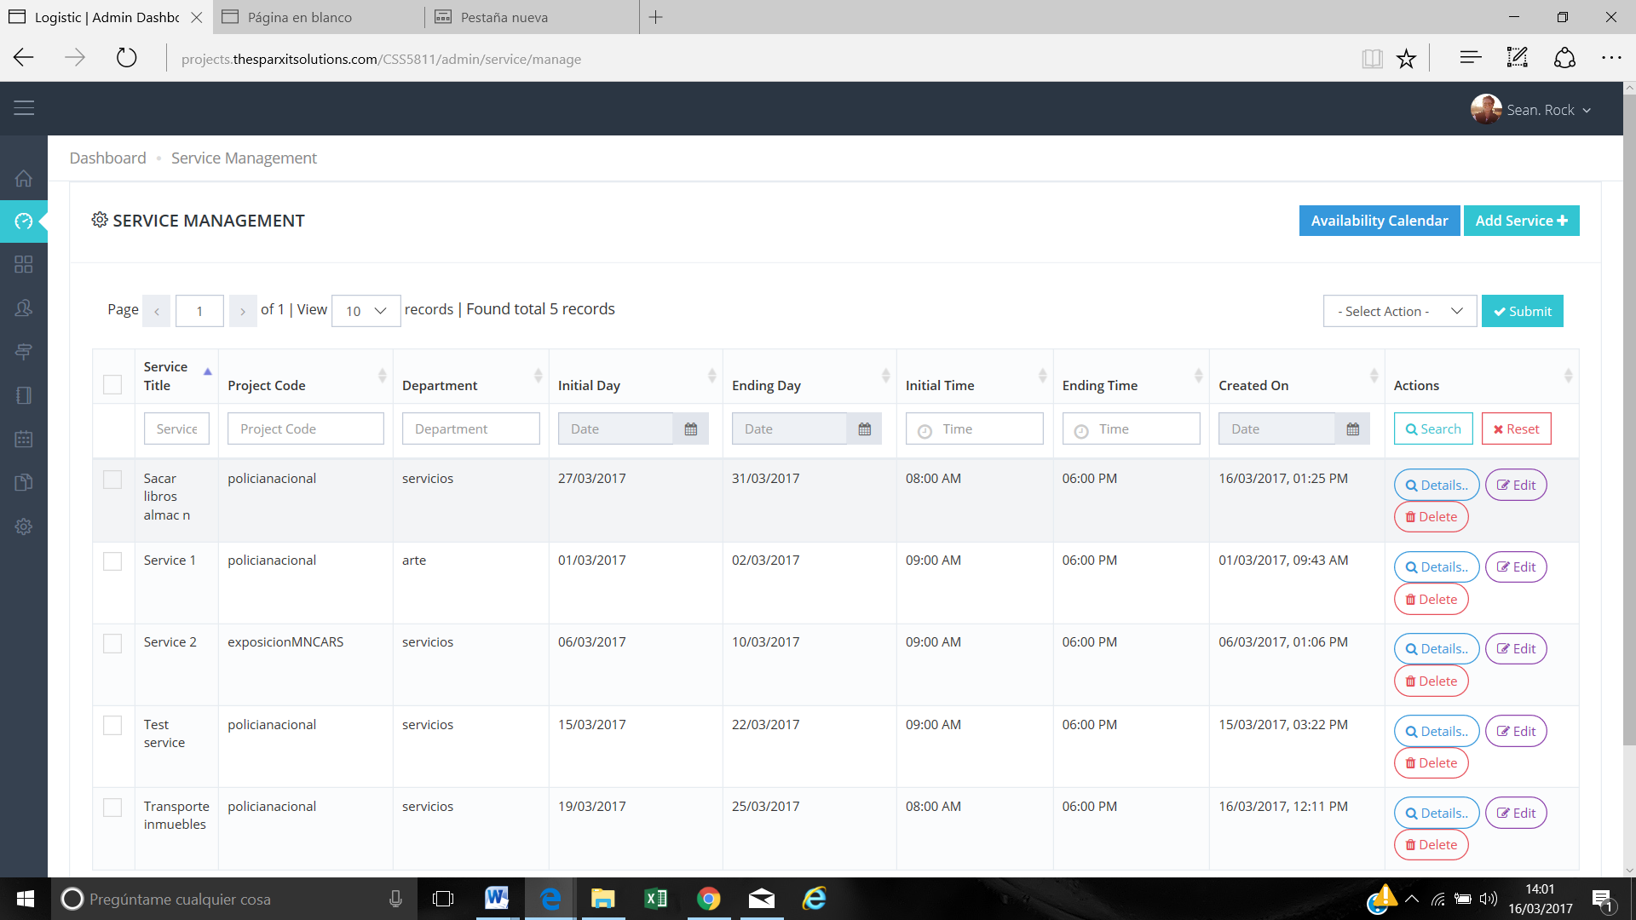

For example we have filtered through one starting day and We cannot see the people and the vehicles assign to this project.

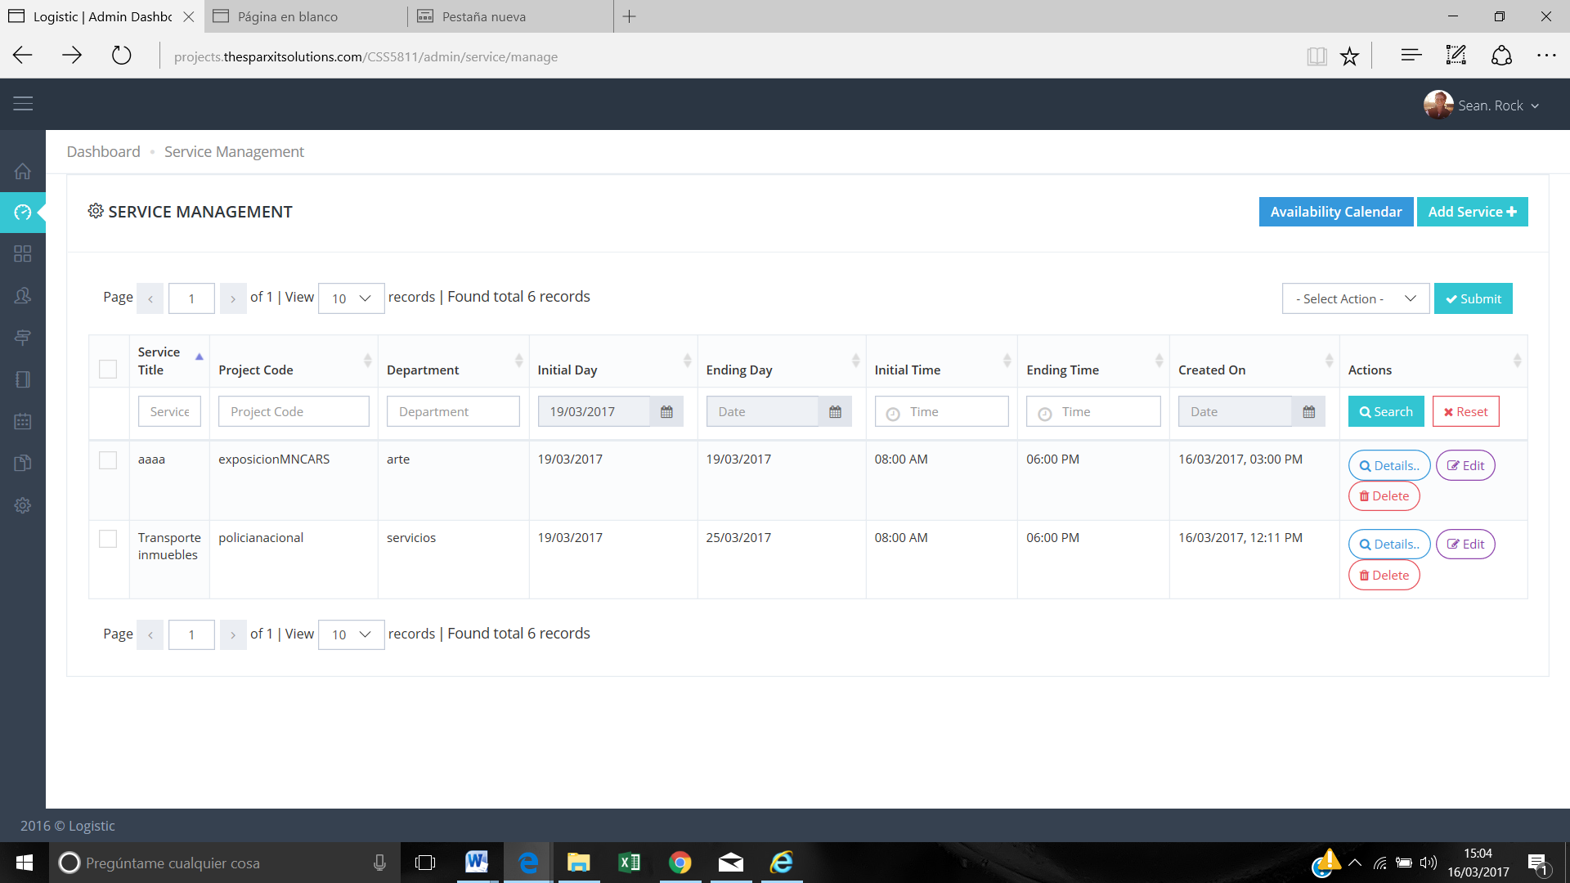

We need to be able to see employee and vehicles without clicking details.

In this screen we want to take out Service Title and Created On and add in this screen Employee and Vehicles assign.

**>> I need layout design in which order it will be display here.. because each service has multiple entries on daily basis. And resources can be modified on daily basis. Eg. 2 employee / 1 vehicle on 1 Feb. And 3 employee / 2 vehicles on 3 Feb. Etc.**

4.- Creating a service in the screen the administrator has to fill obligatory all the fields. Some of them have to be optional for example. It’s obligatory select a vehicle and there are a lot of services without vehicles.

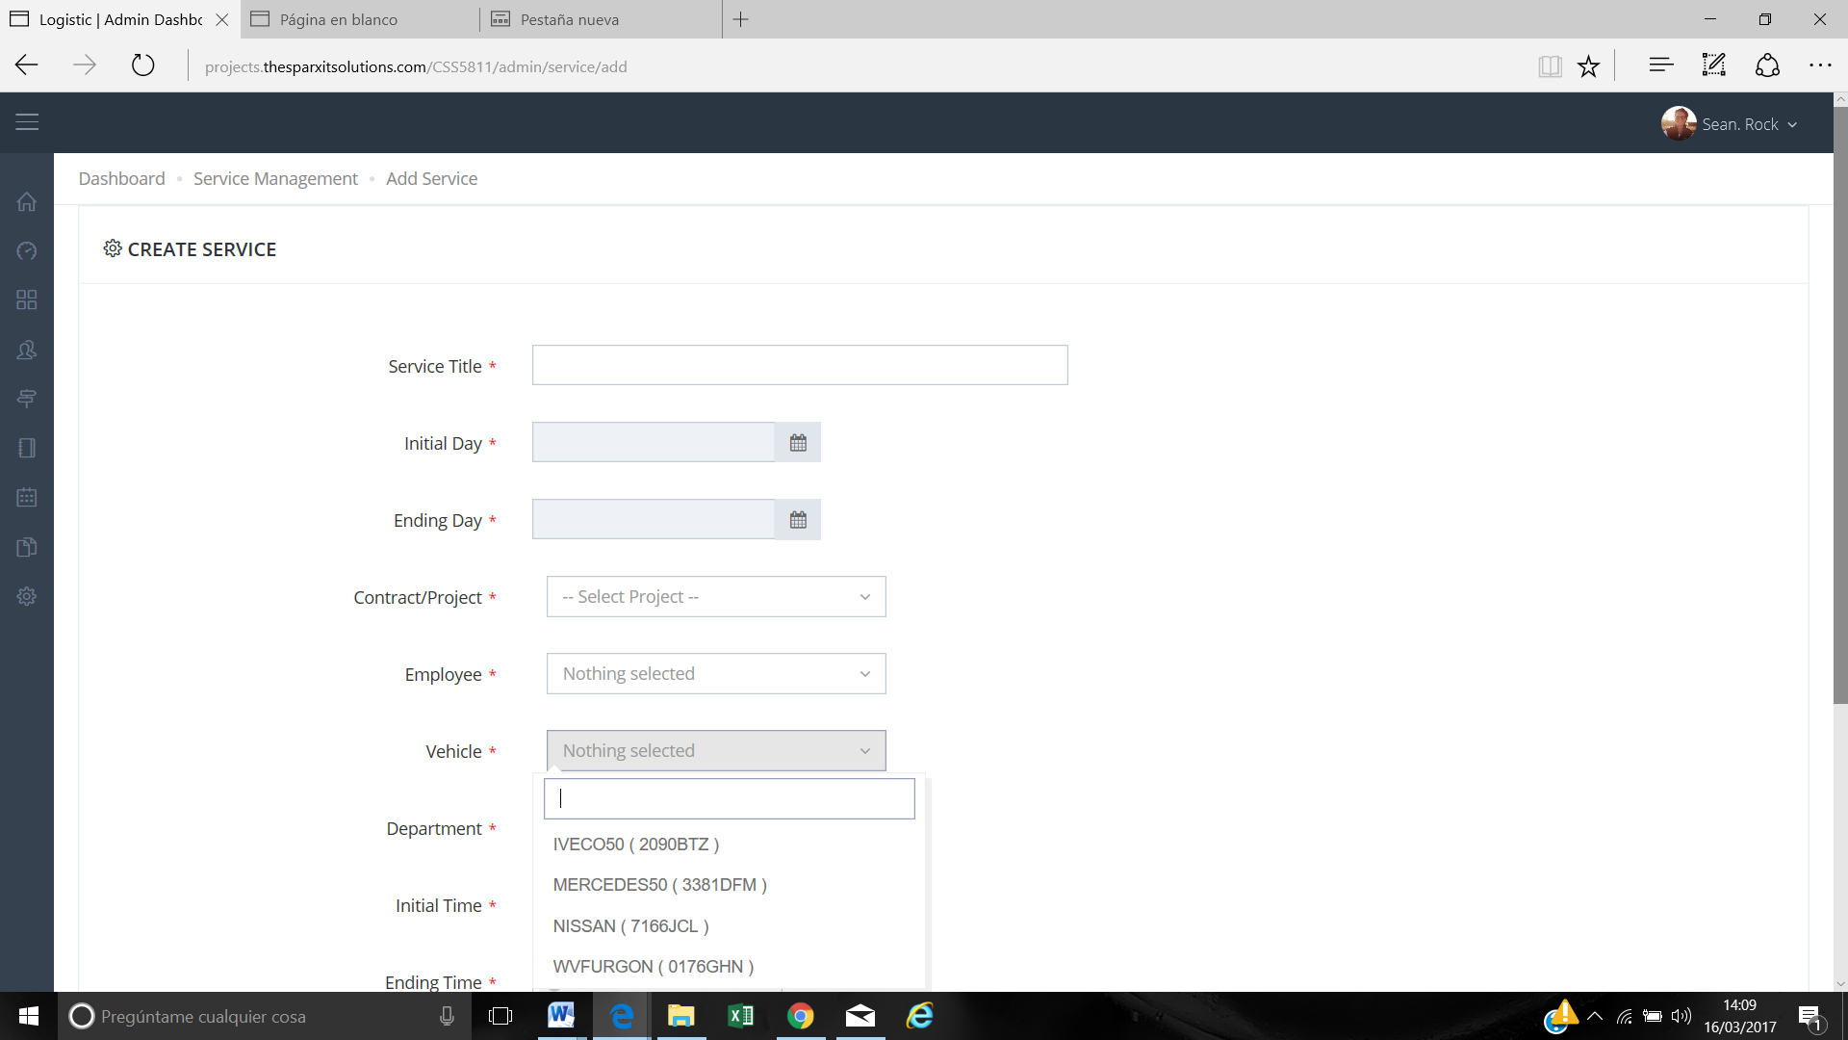

* Service tittle
* Vehicle
* Service description

These areas have to be optional.

**>> We are working on this point.**

5.- The reports have to be able to export them on Excel as well.

**>> It was not discussed in initial scope, it is 30 hours extra scope work.**

6.- When the user opens to one day it’s not possible to see all the personal and vehicles. We need to see them. Done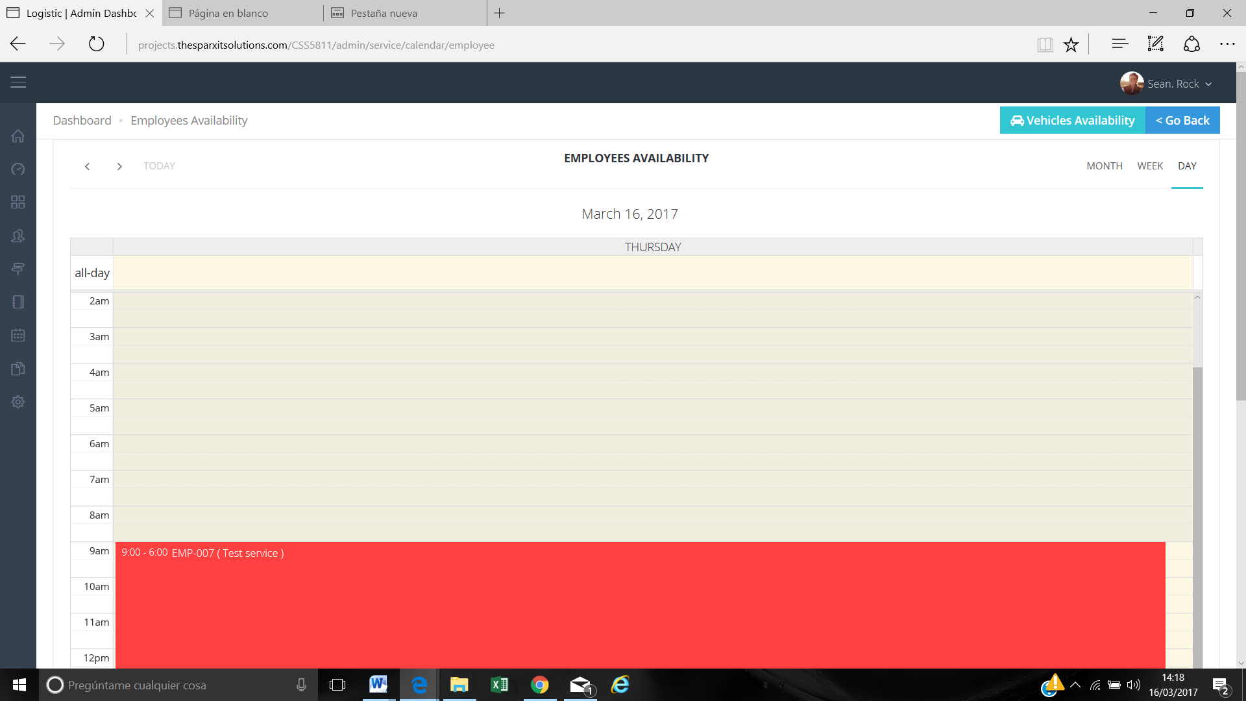

7.- We need to have the available employees in green and unavailable employees in red. -

**>> CSS does not support for coloring drop-down options, we are trying to find solution for this.**

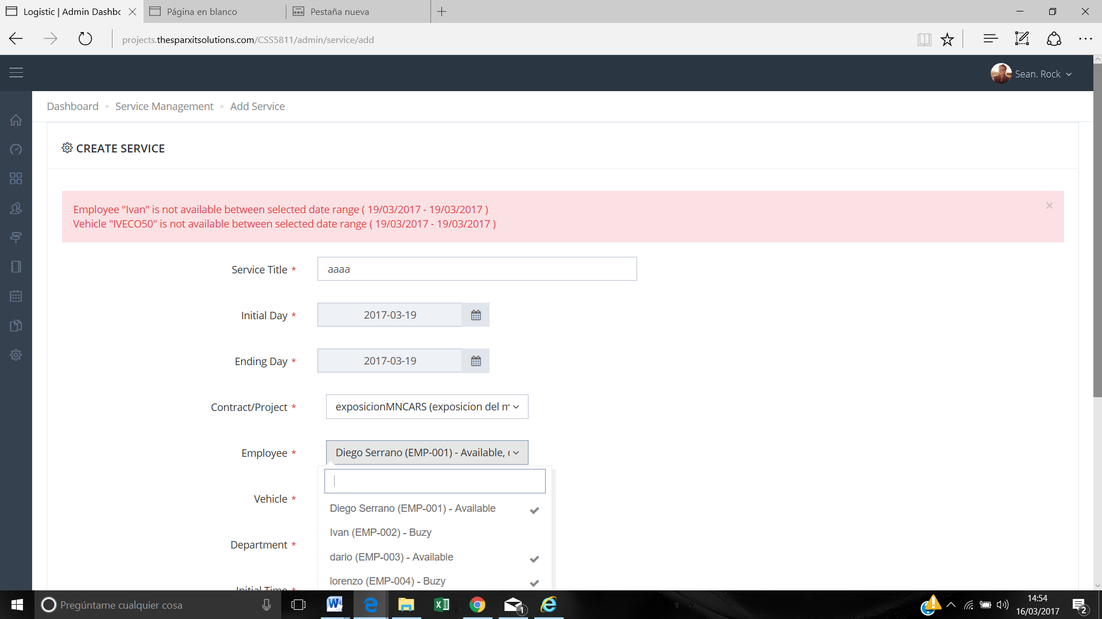

8.- We want to add a picture in the profile of the employee and if the contract is temporary we need to have the ending time of the contract.

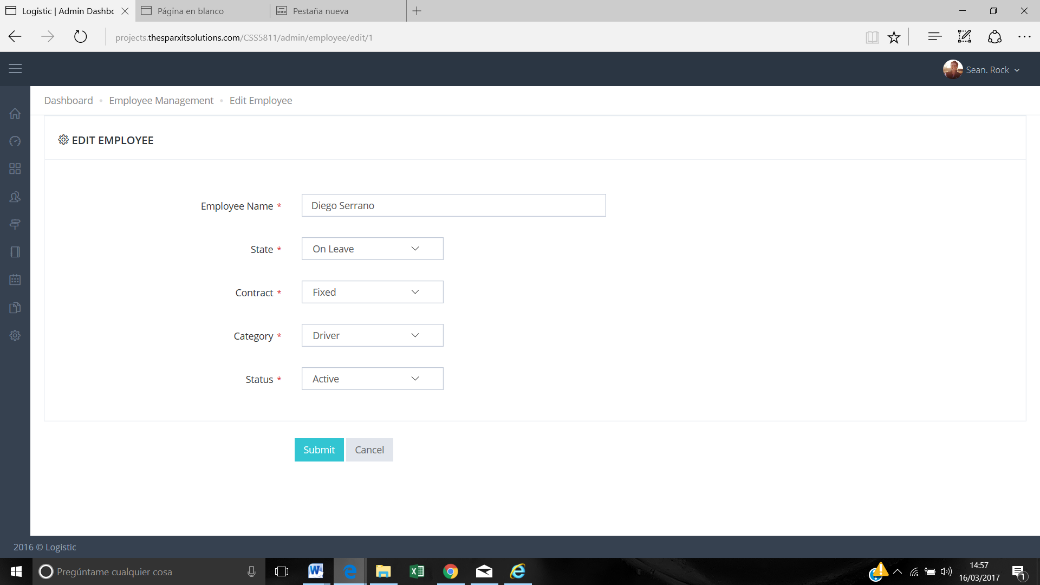

In this screen.

**>> Adding picture into employee module is 10 hours extra scope work. We have to work in add/edit/listing page again.**

**>> In case of temporary contract how end time will work. Please explain your requirement in detail. ( Extra Scope )**

9.- After creating a service the app crashes every time sometimes afterwards the service has been created. But we had to sign up again.

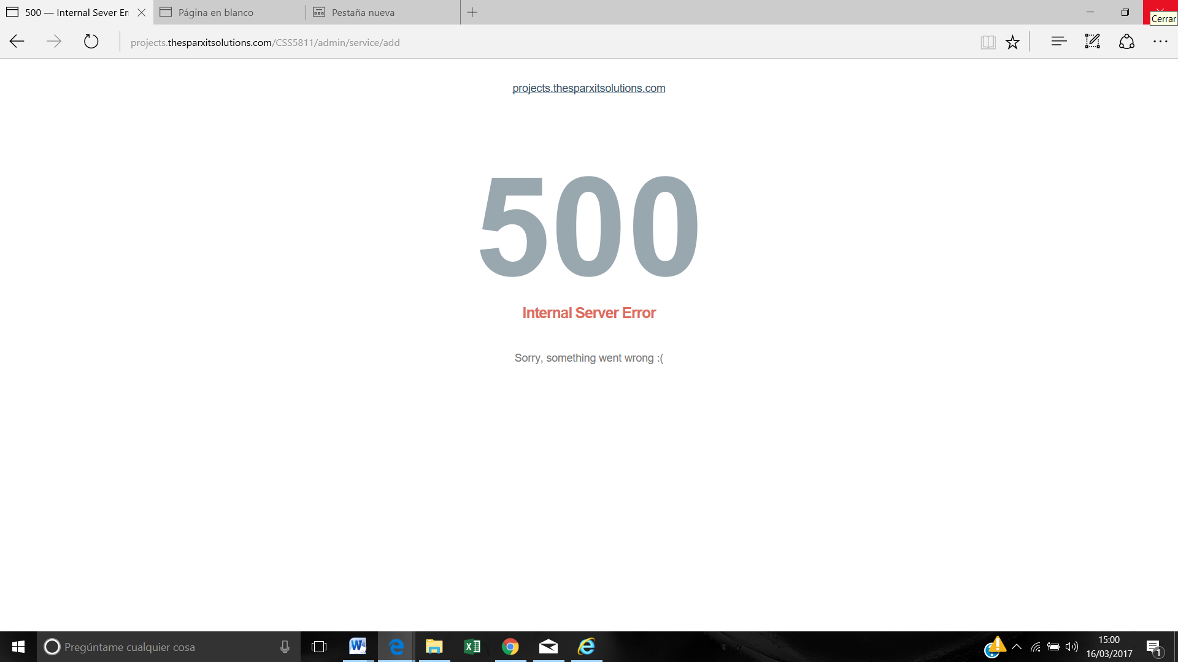

**>> It is server-side internal issue, if you face this issue frequently again. Then letme know I will move the project on other server.**